February 27, 2023

Dear Dr. Carvalho,

On behalf of the author team, I am pleased to submit our revised manuscript, “Impact of the 2014-16 marine heatwave on U.S. and Canada West Coast fisheries: surprises and lessons from key case studies”, for consideration as an Original Article in *Fish and Fisheries*.

We carefully reviewed the comments from you and the reviewers and are grateful for this thoughtful feedback. We address each comment individually below with the original comment shown in black text and the response shown in indented blue text. This feedback and the associated revisions have greatly improved the manuscript.

Briefly, we made the following notable changes to the manuscript text:

1. Revised the case study vignettes to follow a more consistent structure;
2. Added a new section that discusses the broader relevance of our study to other regions;
3. Modified the figures in response to the reviewer feedback and moved Figures 4 and 6 from the initial submission to the supplemental materials.

During the revision process, we also gained access to a version of the Alaska commercial fisheries landings data that divides landings from the Gulf of Alaska (GOA) and the Bering Sea/Aleutian Islands regions. Because the impacts of the 2014-16 marine heatwave were contained to the GOA region, we revised the analysis to only examine these data (note: the analysis of the recreational fisheries landings data was already limited to the GOA). Slight changes to the figures are highlighted below. The results are qualitatively unchanged.

Thank you for your consideration and please let us know if you have any questions.

On behalf of all authors,

Sincerely,

Christopher Free

## 

## Editor

It is important therefore that you address the various concerns as fully as possible, and in particular key aspects relating to the species-specific sections and use of a more implicit and consistent structure, proposed modifications to the Figures, a more comparative consideration of the presented extreme event with other salient events (such comparative consideration is a particular feature of FAF published articles), and the added value that such impacts can have on the long term approach to management in this and any other salient regions (where appropriate generic trends emerge). We look forward to hearing from you in due course and thank you in advance for your interest in FAF.

We are grateful for your thoughtful handling of our manuscript and for this helpful guidance on revising it to address the reviewer feedback. Among other revisions, we:

1. Revised the case study vignettes to follow a more consistent structure;
2. Modified all of the figures in accordance with the reviewer feedback;
3. Added a new section to discuss the relevance of our study to other regions.

During the revision process, we also gained access to a version of the Alaska commercial fisheries landings data that divides landings from the Gulf of Alaska (GOA) and the Bering Sea/Aleutian Islands regions. Because the impacts of the 2014-16 marine heatwave were contained to the GOA region, we revised the analysis to only examine these data (note: the analysis of the recreational fisheries landings data was already limited to the GOA). This resulted in changes to the Alaska portion of Figures 3 and S1. These are shown in the following two pages. We revised the following underlined text to the supplemental methods to reflect this:

“We used annual revenue data from the PacFIN database for the U.S. West Coast (California, Oregon, and Washington) and data provided directly from NOAA for the Gulf of Alaska. We were unable to use the AKFIN database (i.e., the equivalent of PacFIN for Alaska) for Alaska because the AKFIN database only includes crabs and groundfish (i.e., it is less comprehensive), is not species-specific (i.e., it is more generic), and does not separate the Gulf of Alaska from the Bering Sea and Aleutian Islands regions. We focus on the Gulf of Alaska region because this was the region impacted by the 2014-16 marine heatwave.”

The results text did not require adjustment because the patterns remained qualitatively unchanged. The changes to the Alaska portion of Figures 3 and S1 are shown below.

|  |
| --- |
| Original Figure 3 |
| Updated Figure 3 (Alaska portion only) |

|  |
| --- |
| Original Figure S1 |
| Revised Figure S1 (Alaska portion only) |

## Reviewer 1

This is a very well written, informative, interesting, and timely manuscript that reviews impacts of the 2014-16 marine heatwave on U.S. and Canada West Coast fisheries. Novel contributions offered in this manuscript include a comprehensive synthesis of economic impacts and an assessment of key lessons learned about the fishery socio-economic system challenges associated with each of 10 case studies that are briefly reviewed. Strengths of this contribution include the success of this manuscript in effectively describing many contrasting and many common features of the fishery impacts associated with the 2014-16 marine heatwave from Alaska to California. The story is told especially well with very clear writing and an extensive and up to date list of citations. The economic analysis also provides a coast-wide picture of impacts that is likely to include surprises for many readers. Surprises for me included coast-wide (excluding BC) increases in commercial shrimp, CA-OR bivalve, BC CPS, and CA HMS fishery revenues. I suspect that negative impacts of the MHW on West Coast fisheries have tended to receive more attention from the scientific community, resource management agencies, media, and general public, so getting this information out about economic winners and losers is a valuable contribution.

As noted in a few places in this manuscript, some impacts of the 2014-16 MHW appear to have been limited to a select number of years, while others continued to at least 2022. It might be worth noting that episodic climate events like the warm blob may alter ecosystems and fisheries for an undetermined period of time, perhaps long after the climate event has ended. Examples of persistent impacts mentioned in this article include the sustained change in large bluefin landed in California (Fig S1), the persistence of whale entanglement-risk associated Dungeness crab fishery closures (through December 2022), persistence of the California abalone fishery and red urchin fishery closure through 2022, persistence of high anchovy and low sardine biomass in the California Current System, and persistence of low Pacific cod biomass and fishery restrictions in the Gulf of Alaska.

Overall I think this manuscript will make an outstanding contribution to the literature on impacts of marine heatwaves specifically, and more generally to understanding different management responses and challenges in response to climate change. Below I offer a number of comments and suggestions for the authors to consider in revising this manuscript. I recommend that this manuscript be accepted for publication pending minor revisions.

Nate Mantua

NOAA/NMFS

Southwest Fisheries Science Center

Santa Cruz, CA

We are grateful for your close review of our manuscript and for your thoughtful and constructive feedback. We agree with all of your comments and suggestions and detail how we addressed them in the indented blue text below.

Figures:

I found Figures 4 and 6 to be really packed with information, and somewhat challenging to visually interpret without carefully reading the axis labels, legends and figure captions. On the plus side, there is a great deal of information compressed into these figures so a reader can both assess overall color patterns for each sub-region and make comparisons by looking across regions for the same species. I much prefer seeing these figures than tables of numbers. I appreciate the way that these follow the more aggregated information in Figures 3 and 5.

We appreciate this feedback. Because Reviewer 2 also found the figures overly detailed and because they are not discussed in detail in the manuscript, we moved these figures to the supplementary materials for the especially interested reader.

Line colors in Figures 3A and 5A for California and BC are similar on my computer, so doing something to better distinguish them may be warranted. Likewise, I had the same issue with the colors for Meat quality/DA delay and Evisceration order in Fig 8A.

We swapped the colors used for AK and BC so that the lines would be easier to differentiate in Figures 3A and Figure 4A (formerly 5A). A screenshot is provided below.

|  |  |
| --- | --- |
|  |  |
| *Figure 3A* | *Figure 4A (formerly 5A)* |

We also revised the colors used for “evisceration orders” in Figure 6A (formerly 8A) to be easier to differentiate from “meat quality/DA delays”. A screenshot is provided below:

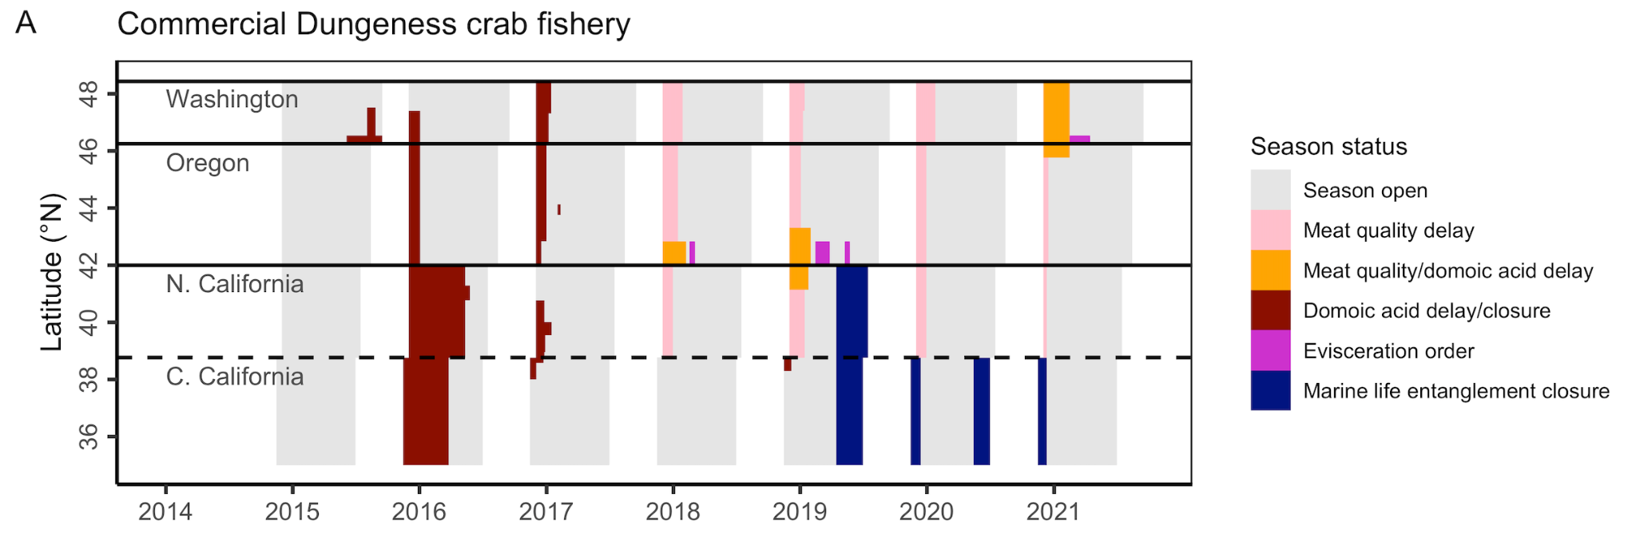

Figure 6 includes data for a CA Arctic char recreational (coastal pelagic) fishery. I don’t think there is an Arctic char fishery of any kind in CA, is there? Maybe those data came from AK?

Indeed, the catch of Arctic char in California has been extremely rare, but it has been reported to occur. Specifically, 18 Arctic char were estimated to have been caught and retained on California private boats in 2013. See snapshot from RecFIN below:

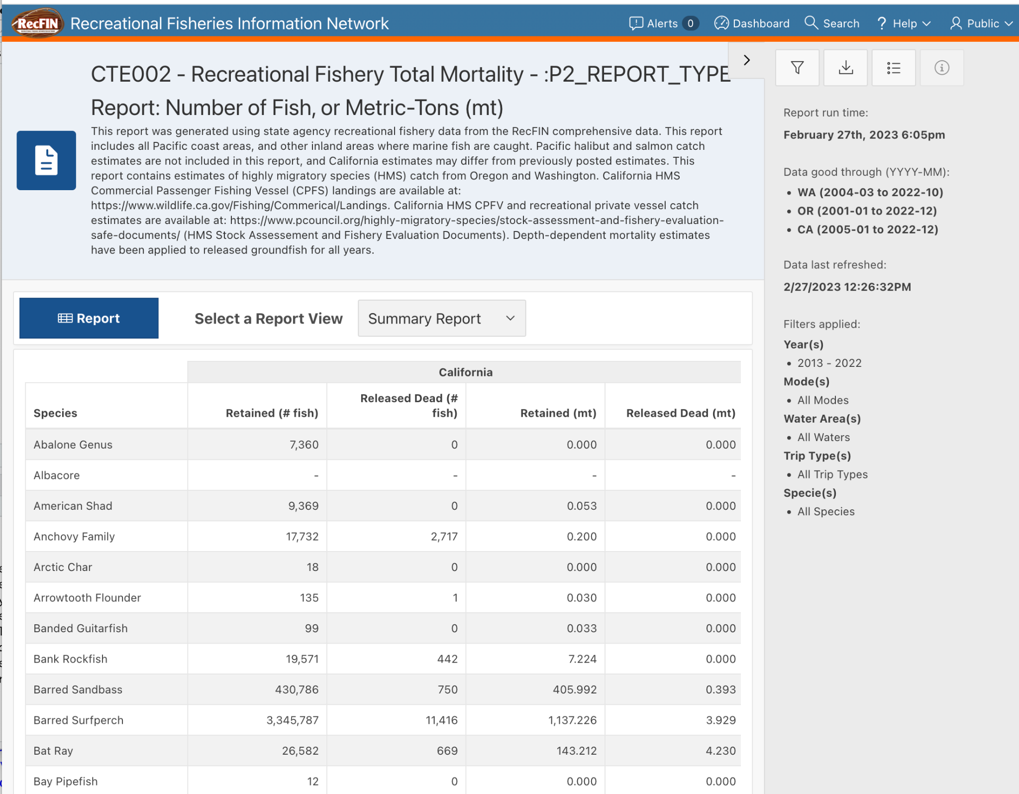

Additional comments (following line numbers):

35-38: I prefer the title as written on this submission, but I also like your alternative on lines 37-38

We appreciate this endorsement and have retained the original title.

53: consider revising this line to “improving the resilience of monitoring and management, and increasing adaptive capacity to future stressors.”

We rewrote this sentence using the suggested language.

57: maybe split off “simulation testing to help guide management decisions” so it can be a stand alone recommendation that supports improved decision-making?

This is a great suggestion. The sentence now reads as follows:

“Key recommendations include: (1) expanding monitoring to enhance mechanistic understanding, provide early warning signals, and improve predictions of impacts; (2) increasing the flexibility, adaptiveness, and inclusiveness of management where possible; (3) using simulation testing to help guide management decisions; and (4) enhancing the adaptive capacity of fishing communities by promoting engagement, flexibility, experimentation, and failsafes.”

130-131: In the "blob initiation region" of the interior Gulf of Alaska, persistent high pressure led to reduced storminess, weak surface winds, reduced heat loss to the atmosphere, reduced vertical mixing, warming and persistent stratification of the surface layer (Bond et al. 2015). The fall 2013 initiation of the warm blob in the Gulf of Alaska did not include weaker than normal alongshore winds off the PNW coast, and near average to cooler than normal nearshore SSTs persisted off the PNW coast persisted into summer 2014. Beginning in early 2014, a distinct and distant upper ocean warming developed in the Southern California Current System (SCCS). The SCCS warming involved reduced alongshore winds and a reduction in coastal upwelling (Zaba and Rudnick, 2016), and it was in fall 2014 these two warm anomaly areas rapidly expanded and merged into a broad pattern of warming that encompassed the entire NE Pacific (DiLorenzo and Mantua, 2016). These are more details than you need for this article, but the description offered here mixes up some key parts of the MHW evolution.

We appreciate this clarification. We significantly edited this paragraph to more accurately describe the initiation of the heatwave and its merger with the separate warming event in the SCCS. The underlined text was significantly revised from the original text:

“The marine heatwave began in fall 2013 as a large “blob” of anomalously warm water in the Gulf of Alaska (**Figure 1**) [(Bond et al., 2015)](https://www.zotero.org/google-docs/?11M836). This warm water pool formed as a result of an unusually persistent ridge of high atmospheric pressure that reduced storminess, weakened surface winds, intensified stratification, and reduced both heat loss to the atmosphere and advection of cooler water into the upper ocean [(Bond et al., 2015)](https://www.zotero.org/google-docs/?u8iLD0). In spring 2014, a separate upper ocean warm pool developed in the distant southern California Current ecosystem, associated with reduced alongshore wind and coastal upwelling. By fall 2014, these two warm water anomalies merged, encompassing much of the Northeast Pacific (Di Lorenzo and Mantua, 2016). The heatwave persisted as a result of a strong El Niño that began in mid-2015 and caused warm conditions to last until summer 2016 in the California Current [(Di Lorenzo & Mantua, 2016; Jacox et al., 2016)](https://www.zotero.org/google-docs/?gZZfS8) and through 2017 in the Gulf of Alaska [(Suryan et al., 2021)](https://www.zotero.org/google-docs/?PGfOfu). Throughout this period, anomalously warm conditions only abated in spring in nearshore upwelling zones during periods of favorable wind stress [(Gentemann et al., 2017)](https://www.zotero.org/google-docs/?3OOXpg). However, cool, nutrient-rich, subarctic source water was locally available before and during the heatwave [(Schroeder et al., 2019)](https://www.zotero.org/google-docs/?P6wOOS). During the southern warming event, weakened winter storms and upwelling-favorable alongshore winds resulted in persistent stratification of the surface layer. This limited the vertical mixing of cold, nutrient-rich, deep water into surface waters, leading to reduced nutrient fluxes into the euphotic zone and deepening of the nutricline in 2014-15 [(Zaba & Rudnick, 2016)](https://www.zotero.org/google-docs/?9l5FKi).”

138: I would not cite Whitney (2015) after discussing nearshore productivity, as that article focused on the transition zone well offshore of the continental shelf (from 130W-170W).

We removed the citation to Whitney (2015) here. This leaves the citations for Delgadillo-Hinojosa et al. (2020) and Peña et al. (2019).

201: seems worth noting that lags between the heatwave event and fisheries impacts are likely to vary widely - for instance range shifts are likely to have small or no lags, but impacts on recruitment for species that enter the fishery age 2+ are likely to exhibit lags in abundance and related landing changes. Noting this here would foreshadow your summary of the rise in tribal salmon fishery federal fishery disaster declarations starting with the 2017 harvest year (lines 241-243).

This is a great suggestion. We added the following underlined text and citation to highlight this:

“This analysis is limited in that it cannot attribute causality, it does not account for lags in heatwave impacts (which may be minimal for range shifts or for especially fast-lived species, or delayed for species that recruit into the fishery at age 2 or older; [White et al., 2022](https://www.zotero.org/google-docs/?VWrTYw)), and it assumes that profits are proportional to revenues, but it still provides useful insights into the identity and rank order of potential heatwave “winners” and “losers”.”

[White, J. W., Barceló, C., Hastings, A., & Botsford, L. W. (2022). Pulse disturbances in age-structured populations: Life history predicts initial impact and recovery time. *Journal of Animal Ecology*, *91*(12), 2370–2383. https://doi.org/10.1111/1365-2656.13828](https://www.zotero.org/google-docs/?WBI5HW)

249-250: You might add that more resilience bolstering actions are needed to mitigate climate impacts on tribal fishery SESs (not just research)

This is an important point. We added the following underlined text to capture this:

“More cooperative research is necessary to characterize the impacts of climate change and heatwaves on Indigenous communities and to identify and implement actions for bolstering their resilience to these impacts (Mason et al. 2022).”

Mason, J. G., Eurich, J. G., Lau, J. D., Battista, W., Free, C. M., Mills, K. E., Tokunaga, K., Zhao, L. Z., Dickey-Collas, M., Valle, M., Pecl, G. T., Cinner, J. E., McClanahan, T. R., Allison, E. H., Friedman, W. R., Silva, C., Yáñez, E., Barbieri, M. Á., & Kleisner, K. M. (2022). Attributes of climate resilience in fisheries: From theory to practice. *Fish and Fisheries*, *23*(3), 522–544. https://doi.org/10.1111/faf.12630

308-309: The authors accurately note that the abundance for SRFC and KRFC forecasts do not explicitly involve environmental covariates despite their known importance. However, correlations between environmental covariates and salmon abundance do not guarantee better abundance forecast performance - for example, see Winship et al.’s (2005) evaluation for Sacramento River fall Chinook. Wainwright (2021) also provides an interesting and relevant analysis of Oregon Production Index coho salmon productivity and climate. Winship et al paper showed that a simpler model (without environmental variables) had the best forecast overall forecast performance for SRFC. Wainwright noted that "Results demonstrate that predictive skill of EBF [Environment-Based Forecast] models is often ephemeral, arising and falling suddenly across time".

Winship, AJ, MR O’Farrell, WH Satterthwaite, BK Wells, and MS Mohr. 2015 Expected future performance of salmon abundance forecast models with varying complexity. Can. J. Fish. Aquat. Sci. 72: 1–13 (2015) [dx.doi.org/10.1139/cjfas-2014-0247](http://dx.doi.org/10.1139/cjfas-2014-0247)

Wainwright, TC. 2021. Ephemeral relationships in salmon forecasting: A cautionary tale. Progress in Oceanography,193. <https://doi.org/10.1016/j.pocean.2021.102522>

We added the following underlined text to capture these important points and citations:

“In general terms, both forecast models are based on the previous year’s returns (Peterman, 1982; Winship et al., 2015); they do not explicitly include environmental covariates, despite their known importance (Friedman et al., 2019; Wells et al., 2016), due partially to concerns about their long-term predictive power (Winship et al. 2015; Wainwright 2021).”

311: The marine heatwave would have primarily affected fisheries and the number of spawners from 2016-2019 for both Sacramento River (SRFC) and Klamath River fall Chinook (KRFC). Thus the forecasts for those management years are of interest.

We appreciate this clarification. We edited the text to read:

“The marine heatwave impacted juveniles entering the ocean in 2014-16, which means that the impacts of the heatwave were not realized until these cohorts returned as adults, primarily in 2016-19”.

The sentence previously read:

“The marine heatwave impacted juveniles entering the ocean in 2014-16 from both these stocks, with cohorts predominantly returning as adults in 2016-18 in the Sacramento and 2017-2019 in the Klamath River.”

311-318, 325-327: Looking at management years 2016-19, KRFC were over forecast in 2016, 18, 19, but slightly under forecast in 2017. SRFC were over forecast in 2016 and 17, almost perfectly forecast in 2018, and under forecast in 2019. The key point here is that this period saw more frequent over forecast than under forecast errors, but error signs and magnitude varied by year and stock.

This is a useful observation and we rewrote this sentence to clarify that there was a general tendency for the model to over forecast during this period, though for some stocks and years, there were the noted exceptions. These two sentence now read:

“The marine heatwave impacted juveniles entering the ocean in 2014-16, which means that the impacts of the heatwave were not realized until these cohorts returned as adults in 2016-2019. During the return period, the models for each stock successfully forecasted low preseason abundance, but tended to overestimate the actual return size (**Figure 6D**).”

They previously read:

“The marine heatwave impacted juveniles entering the ocean in 2014-16 from both these stocks, with cohorts predominantly returning as adults in 2016-18 in the Sacramento and 2017-2019 in the Klamath River. Both stocks’ models forecasted low preseason abundance, but both also nonetheless overestimated actual return size (**Figure 6D**).”

330-334: Given forecast and fishery model uncertainty, building in precautionary fishery management measures and restoring resilience in the salmon production system to all climate extremes (drought, flood, marine and terrestrial heat waves via freshwater and estuary habitat restoration) is something that should be prioritized (you could cite Munsch et al. 2022 here).

This is a great point. We greatly expanded this text, which now reads:

“This highlights the importance of incorporating additional precaution to account for uncertainty (Satterthwaite & Shelton, 2023) and enhancing the resilience of the salmon production to all climate impacts (e.g., drought, flood, terrestrial heatwaves) through freshwater and estuarine habitat restoration (Munsch et al. 2022; Sturrock et al. 2019). It also highlights the importance of increasing community resilience by, for example, promoting the ability to switch to alternative fisheries.”

Satterthwaite, W. H., & Shelton, A. O. (in press). Methods for assessing and responding to bias and uncertainty in U.S. West Coast salmon abundance forecasts. *Fisheries Research*.

Sturrock, A. M., Satterthwaite, W. H., Cervantes-Yoshida, K. M., Huber, E. R., Sturrock, H. J. W., Nusslé, S., & Carlson, S. M. (2019). Eight Decades of Hatchery Salmon Releases in the California Central Valley: Factors Influencing Straying and Resilience. *Fisheries*, *44*(9), 433–444. https://doi.org/10.1002/fsh.10267

It previously read:

“This highlights the importance of restoring freshwater habitats to buffer against poor ocean conditions and increasing community resilience through additional policy actions that, for example, promote the ability to switch to alternative fisheries or reform disaster relief to be more accurate, timely, and equitable.”

390-392: I believe that step 2 of the 4 listed here is well underway with the Rapid Assessment and Mitigation Program (RAMP) that includes near real-time monitoring, a multi-stakeholder California Dungeness crab Fishing Gear Working Group that makes recommendations to CDFW's Director, and in-season assessments that impact in-season management actions: see <https://www.opc.ca.gov/risk-assessment-and-mitigation-program-ramp/> and <https://wildlife.ca.gov/Conservation/Marine/Whale-Safe-Fisheries>

We replaced “developing” with “continuing to refine” and added a reference to the RAMP rules to clarify that significant headway has already been made on this point. We also rearranged (moved the stakeholder bit) and expanded the text (added the “minimize impacts on fishers” bit) to help address the comment below.

The text now reads:

“(2) continuing to refine entanglement prevention strategies that are co-developed with stakeholders and are proven to be effective, robust or adaptable to changing conditions, and minimally impactful on fishers, (CDFW 2020; Samhouri et al., 2021);”

CDFW (2020) Risk Assessment Mitigation Program: Commercial Dungeness Crab Fishery, 132.8. California Code of Regulations, Title 14 (2020). <https://nrm.dfg.ca.gov/FileHandler.ashx?DocumentID=184189&inline>

It previously read:

“(2) developing entanglement prevention strategies that are proven to be effective, robust or adaptable to changing conditions, and co-developed with stakeholders (Samhouri et al., 2021);”

365-396: You might also add that indirect effects of the MHW diminished the effectiveness of different management strategies to resolve trade-offs between conservation benefits and costs to the Dungeness crab fishery (Samhouri et al. 2021). This situation has persisted to date with the delayed opening of the fall 2022 crab fishery due to the presence of large numbers of whales in Central California’s crab fishing areas (as detailed on [ca.gov](http://ca.gov/) web-site listed above). While the RAMP has been very effective at reducing whale entanglements, the delayed season openings continue to bring negative economic impacts to the commercial fisheries.

We added the following underlined text to capture this point:

“These events prompted an overhaul of California’s entanglement risk management program (CDFW 2020), which has implemented early closures in the last four fishing seasons (2018-19 to 2021-22) to reduce entanglement risk. This has been effective at reducing entanglements but at significant cost to fishers [(Seary et al., 2022)](https://www.zotero.org/google-docs/?ZJdtbx).

We hope that the increased clarity in point #2 (addressed in the comment above) helps to better highlight the value of identifying strategies that are either robust or adaptable to changing conditions, such as those experienced during the 2014-16 heatwave.

378-381: Santora et al (2020) showed that the dramatic spike in whale entanglements was due to a MHW-induced change in forage availability (specifically a reduction in the availability of krill along the shelf-break and submarine canyon heads) at the same time there was an increased concentration of anchovies inside the shelf-break where the crab fishery (and many other fisheries) are conducted. Humpback whales typically feed on krill, but when krill were scarce they switched to feeding on inshore anchovies, which increased the spatial overlap with fishing activity. The already boosted space-time overlap of whales and fishing gear was further intensified by the HAB-induced delayed opening of the 2015-16 Dungeness crab fishery, but that was only a compounding issue in the 2015-16 season. As shown in your Figure 8A, California’s Dungeness crab fishery experienced delayed openings in 2019-2021 (and 2022, but that just happened!) in response to high whale entanglement risks.

We added the following underlined text to succinctly capture these additional mechanistic details:

“Second, these delays led the fishery to open when humpback whales were returning north, intensifying the overlap between nearshore fishing and migrating whales. This overlap was further exacerbated by the heatwave-induced nearshore compression of coastal upwelling, which caused spatial shifts in forage species availability (i.e., offshore krill abundance decreased while inshore anchovy abundance increased), leading to a dramatic spike in whale entanglements in crab pot lines [(Santora et al., 2020)](https://www.zotero.org/google-docs/?ms7EAy).”

406: Rykaczewski and Checkley (2008) hypothesized that stronger offshore/open ocean upwelling (caused by wind-stress curl, rather than equatorward alongshore winds) during warm periods benefited the production of small plankton favored by sardine.

We deleted this text in the process of shortening and reorganizing the case studies.

512-513: Is it possible that ODFW’s efforts to improve stock assessments and monitoring are actually addressing climate change impacts by better tracking the shrimp stock status? Isn’t improved monitoring, along with rapid-assessment, of short-lived species likely to provide better decision-support information than what you would get when you are faced with uncertainty in both climate forecasts and environmentally-based shrimp forecasts?

This is a really interesting point. We added the following underlined text to make this point and further broaden the relevance of the case study for short-lived species:

“Although the Oregon Department of Fish and Wildlife identified revisiting the relationship between shrimp recruitment and environmental conditions as a top research priority [(Groth et al., 2017)](https://www.zotero.org/google-docs/?Aw0BuD), it also highlighted that continued monitoring and improved stock assessment are, perhaps, more important to near-term fisheries outcomes. In fact, improved monitoring and more frequent assessments may explain the apparent resilience of these stocks to climate change, as rapid observations and assessments may provide more useful decision-support information than climate-linked forecasts for short-lived species. This case study highlights that: (1) global markets and lagged population dynamics can potentially mitigate (or, in other situations, exacerbate) heatwave impacts; (2) innovation by fishermen can overcome some negative heatwave impacts; and (3) addressing climate impacts may not be the highest priority if there are more pressing concerns (e.g., improving stock assessments, especially for short-lived species).”

653: climate (or other) stressor

We added the suggested text.

1429-30: please specify which of the 3 Free et al (2022) articles are being cited here (I think it is the Harmful Algae article)

Thank you for catching this. This is the *Harmful Algae* paper. We updated the citation.

## Reviewer 2

GENERAL ASSESSMENT

This paper aims at providing a synthesis of the ecological and economic consequences of the heatwave occurred in 2014-2016 in the Northeast Pacific affecting the marine ecosystems and the fisheries of the U.S and Canada west coast. The authors provide a review of the main ecological changes observed and main impacts on the most representative fisheries resources and human livelihoods. The authors concluded with a section illustrating the lessons learned at different levels: monitoring, management, and for improving the adaptive capacity of the fishing communities.

I liked a lot the manuscript as it can be an illustrative example of the implications and management applications that heatwaves and other extreme events related to climate change can have in other regions of the world. However, there are numerous elements that, to my understanding, must be improved to make this contribution more useful of readers. These mainly affect the presentation and organization of the material presented.

We are grateful for your close review of our manuscript and for your thoughtful and constructive feedback. We agree with all of your comments and suggestions and detail how we addressed them in the indented blue text below.

MAJOR (MODERATE) ISSUES

Species-specific sections: There is a strong heterogeneity among the species specific examples (case studies), which should follow more consistently the same structure with information on the (lines 265-268): i) ecological process that trigger the impact of the fishery, ii) the a succinct overview of the impact on the fishery, iii) the response of the management, and iv) the lessons learnt for improving resilience on this specific recourse. However, many case studies provide a very extensive description of the history of the fishery with unnecessary information (many numbers) that difficult the capacity of the reader to take the most important messages in iii) and iv). I recommend the authors to make cases studies more succinct and homogeneous among them.

We took several actions to address this important point.

First, we rearranged the presentation of the case studies to follow a more purposeful order (see response to comment below for details; comment = “Organize the Figure 8…”). This enabled us to cut words from the case studies by avoiding repetitive text.

Second, we carefully reviewed the case studies and removed unnecessary information and numbers, which also reduced the word count and improved clarity.

Third, we edited the case studies to follow the structure proposed in the comment, which reflects the structure we also describe in the introduction to the case studies:

“In each case study, we provide a brief overview of the fishery, the impact of the heatwave on the fishery, the response of industry and management to these impacts, and the revealed opportunities for improving resilience to future heatwaves and climate change.”

These edits greatly improved consistency, clarity, and brevity. Overall, we removed 369 words from Sections 3 and 4, reducing a total of 5590 words to 5221 words.

Section 3: Socio-economic impacts. I’ve realized that authors have carefully avoid to anticipate information that can results repetitive with that provided in the following case studies. However, I think that there is still room to avoid a bit more some repetition. Figures 3 and 5 are very illustrative in this section while Figures 4 and 6 have too much information, with very small fonts and not used at all in the text. I suggest to allocate figures 4 and 6 in the Supplementary Material.

We significantly edited Sections 3 and 4 to avoid repetition. Overall, we removed 369 words, reducing the sections from a joint total of 5590 words to 5221 words.

Because Reviewer 2 also found Figures 4 and 6 to be overly detailed and because they are not discussed in detail in the manuscript, we moved these figures to the supplementary materials for the especially interested reader.

Section 5 – lessons learned: This section is very illustrative but it would be helped by a Table summarizing the main elements in 5.1, 5.2. and 5.3. In Section 5.3, some information related to the potential limitations to the implementation of the measures proposed would be useful.

We added a table to the supplementary materials (**Table S1**) that summarizes the principles recommended in these sections. The table also provides a practical example of how each principle might be implemented. We added this table to the supplementary material rather than to the main text because, while it is extremely useful (it is very easy to absorb), it directly repeats the text already written in section 5.

We added the following underlined text to Section 5.3 to describe additional limitations of the proposed actions for enhancing adaptive capacity in fishing communities:

“Because adaptive capacity depends on social and demographic factors that are heterogeneous across West Coast fishing communities [(Koehn et al., 2022)](https://www.zotero.org/google-docs/?axIZ2l), the success of the suggested strategies will be context dependent. Communities with the lowest adaptive capacity typically have lower incomes, higher poverty rates, and higher unemployment. Because economic assets are a key component of adaptive capacity, communities with more financial assets are more likely to be able to take advantage of opportunities like Exempted Fishing Permits. Moreover, in California fishing communities, low adaptive capacity was related to having a high percent of persons of minority and a high percent of the population that does not speak English well [(Koehn et al., 2022)](https://www.zotero.org/google-docs/?lmu2ZK), which can lead to additional barriers to participating in fisheries management processes or learning about new programs. Beyond focusing on financial assets, strategies that enhance social networks, education, and agency can also improve adaptive capacity of fishing communities [(Barnes et al., 2020)](https://www.zotero.org/google-docs/?C8dAeU). In addition to social considerations, easing access to permits will only help communities in locations where new or alternative target species are available [(Fisher et al., 2021)](https://www.zotero.org/google-docs/?akEvxs).”

Surprises – Authors highlight it the title and the abstract the surprising challenges and unexpected impacts. They are now dispersed in the different case studies, while it would be more helpful to have them compiled and synthesized in an independent section.

We very much appreciate this point but have opted not to add a standalone surprises section. The paper is already quite long and we preferred to use all additional text space to address the very valuable point that you make in the next comment: i.e., the need to connect the lessons learned from the 2014-16 Northeast Pacific marine heatwave to other regions and other categories of extreme events. In our view, each of the selected case studies was a surprise and the “lessons learned” sections thus represent synthesized lessons for addressing surprising challenges and unexpected impacts.

Contextualize this HW with other HWs and extreme events. While we now know that there are many more climate change impacts beyond warming, it would be nice to contextualize this HW with others and other extreme events as there is a diversity in these impacts and they often tend to be grouped under the term ‘extreme events’. However, to my understanding, this particular HW was temporally and spatially more extensive compared with other HWs that can last for few weeks, which could be indeed more comparable to winter extreme events that can last for few days or a week. This is important from the perspective of a reader that try to establish parallelisms (and maybe apply some of the measures and lessons learned) with events occurred in other locations.

We added a significant new subsection (~800 words) to section “5. Lessons learned” called “5.4. Lessons for and from other regions” to describe the implications of the lessons learned from 2014-16 Northeast Pacific fisheries for other regions and also the lessons learned from heatwaves in other regions for the Northeast Pacific region.

HW are not turning into the new and exclusive environmental influence on fisheries. Sometimes, one feels that authors call for a change in the paradigm in regards the influence of environment on fisheries to be from now on focused in HWs. Lessons learnt should complement and have added value on the long-term knowledge acquired in this region.

We added the following underlined text to the conclusions section to emphasize that the success of climate-adaptive fisheries management depends on an effective foundation of traditional fisheries management measures:

“Furthermore, the success of these improvements depends on an effective foundation of traditional fisheries management measures [(Melnychuk et al., 2021)](https://www.zotero.org/google-docs/?kh77Dc), which have both improved fisheries outcomes [(Hilborn et al., 2020)](https://www.zotero.org/google-docs/?dZjdLD) and conferred climate resilience [(Free et al., 2019)](https://www.zotero.org/google-docs/?Vbg5HA). Investments in both traditional and climate-adaptive fisheries management will thus be vital to ensuring that fisheries continue to support livelihoods, food, and nutrition for billions of people, despite climate change [(Costello et al., 2020; Free, Cabral, et al., 2022)](https://www.zotero.org/google-docs/?KQTu6U).”

Hilborn, R., Amoroso, R. O., Anderson, C. M., Baum, J. K., Branch, T. A., Costello, C., de Moor, C. L., Faraj, A., Hively, D., Jensen, O. P., Kurota, H., Little, L. R., Mace, P., McClanahan, T., Melnychuk, M. C., Minto, C., Osio, G. C., Parma, A. M., Pons, M., … Ye, Y. (2020). Effective fisheries management instrumental in improving fish stock status. Proceedings of the National Academy of Sciences, 117(4), 2218–2224. https://doi.org/10.1073/pnas.1909726116

Melnychuk, M. C., Kurota, H., Mace, P. M., Pons, M., Minto, C., Osio, G. C., Jensen, O. P., de Moor, C. L., Parma, A. M., Richard Little, L., Hively, D., Ashbrook, C. E., Baker, N., Amoroso, R. O., Branch, T. A., Anderson, C. M., Szuwalski, C. S., Baum, J. K., McClanahan, T. R., … Hilborn, R. (2021). Identifying management actions that promote sustainable fisheries. Nature Sustainability, 4(5), Article 5. https://doi.org/10.1038/s41893-020-00668-1

Free, C. M., Thorson, J. T., Pinsky, M. L., Oken, K. L., Wiedenmann, J., & Jensen, O. P. (2019). Impacts of historical warming on marine fisheries production. Science, 363(6430), 979–983. https://doi.org/10.1126/science.aau1758

Free, C. M., Cabral, R. B., Froehlich, H. E., Battista, W., Ojea, E., O’Reilly, E., Palardy, J. E., García Molinos, J., Siegel, K. J., Arnason, R., Juinio-Meñez, M. A., Fabricius, K., Turley, C., & Gaines, S. D. (2022). Expanding ocean food production under climate change. Nature, 605(7910), 490–496. https://doi.org/10.1038/s41586-022-04674-5

MAJOR ISSUES

Data: Some description of data used in Section 3 and how it has been structured and handled is needed. It seems that some information should be available in the SM, but it does not appear there.

We addressed this comment in three ways.

First, we expanded the headers for each of the analyzed datasets to indicate the figure in which each dataset is featured. Thus, the data used in Section 3 are now highlighted under the following section headers: *“Commercial revenues data (Figures 3 & S1)”* and *“Recreational landings data (Figures 4 & S2)”*. We arranged the dataset descriptions to match the order in which they are presented in the figures.

Second, we added new text to describe the following previously undescribed datasets: *“Sea surface temperature data (Figure 1)”*, “*Northern anchovy index of abundance data (Figure S3)*”, and “*Pacific bluefin tuna trophy size fish data (Figure S4)”.*

Third, we expanded the descriptions to include information that was previously missing. A few examples of additions added are provided below:

To disaster data: “These data describe information on every U.S. federal fisheries disaster declaration occurring from 1989-2020, including information on the fishery impacted, the cause of the disaster, the amount of relief money requested and awarded, and other relevant information.”

To Dungeness crab data: “These data describe the location and duration of every closure (or evisceration order) in the West Coast Dungeness crab fishery from 2014-2021.”

Organize the Figure 8 according to the sequence of presentation of the case studies, or present the case studies in a different order otherwise.

This really helpful comment triggered a number of changes to the text and figures.

First, it led us to think carefully about the order in which the case studies are presented. As a result, we slightly rearranged the case study order and then propagated this order into Figures 5, 6, and 7 (formerly Figures 7, 8, 9). The only exception is in Figure 6, where the width of the Dungeness crab panel demands an entire row, forcing us to make this figure slightly deviate from the true case study order.

Another benefit of this careful thinking about case study order was that it led us to add an additional element to Figure 5 (formerly Figure 7) to separate the positive impacts associated with range shifts from those associated with recruitment spikes. This is a useful tool for helping the reader to see connections between the case studies.

We carefully reread and edited the text to ensure that rearranging the case study order did not impact clarity by changing the order in which information is presented.

Lines 294-298: It reads as the work done by previous research is not valid anymore, and I doubt this is the case. I think that lessons learned at all levels in the HW should help to complement or revise previous research not to invalid them.

We edited this sentence to clarify that we are just saying that historical relationships derived based on historical conditions become less reliable when they are applied to non-analog (i.e., novel, unprecedented conditions) conditions. The cited paper shows this, i.e., we are not invalidating the cited paper. The sentence now reads:

“Second, a forward-looking perspective is needed: for instance, recruitment projections based on historical observations and relationships become less informative when applied to unprecedented ocean conditions [(Litzow et al., 2021)](https://www.zotero.org/google-docs/?SWEOP6).”

Previously, it read:

“Second, a forward-looking perspective is needed: for instance, recruitment projections based on historical observations become less informative as we encounter unprecedented ocean conditions [(Litzow et al., 2021)](https://www.zotero.org/google-docs/?SWEOP6).”

Line 356: Revise this at the time of reviewing the ms.

We can confirm that the sardine fishery remains closed at the time of resubmission.

Line 414: A panel on anchovy is missing in Figure 9.

This is a good point. We added the following figure to the supplementary materials (**Figure S3**) to illustrate the anchovy portion of the sardine-anchovy case study:

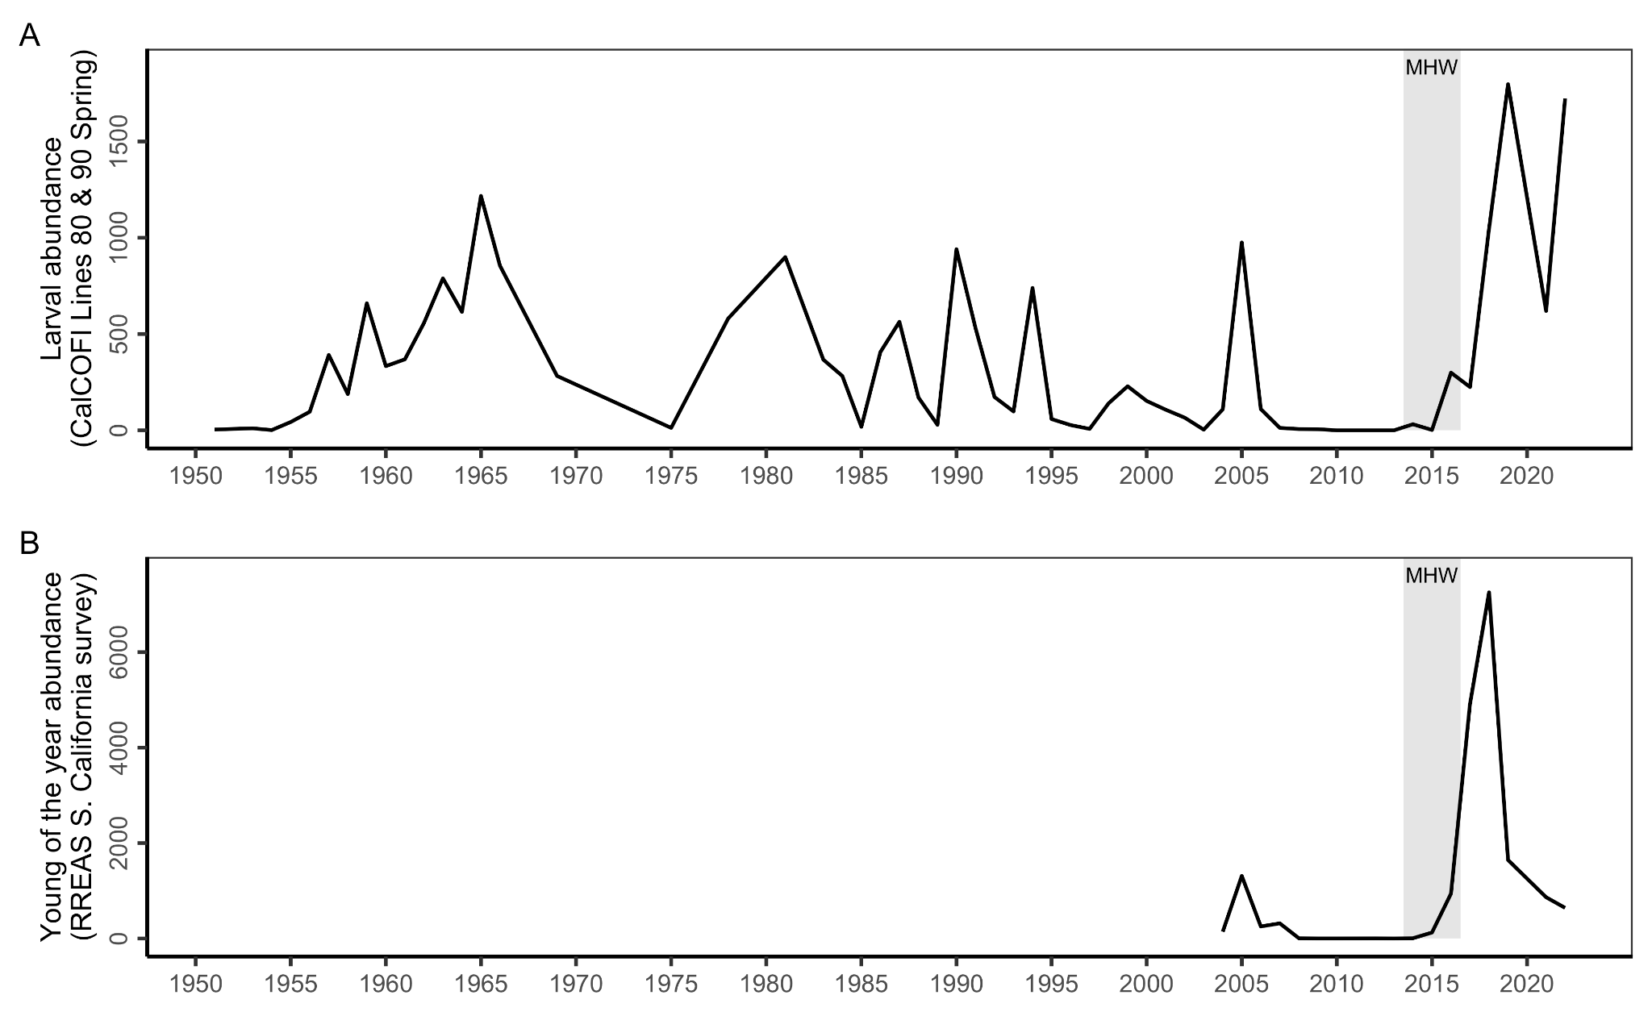

We added the following underlined text to the caption of Figure 6 (formerly Figure 8), where the sardine portion of the sardine-anchovy case study is featured, to refer the reader to the new figure illustrating the anchovy portion of the case study:

“Panel **E** shows the collapse of the commercial Pacific sardine fishery and its closure during the heatwave (see **Figure S3** for the increase in Northern anchovy documented in this case study).”

Line 425-426: No clear the role of the HW in the sardine decline.

Yes, this is correct: the impact of the heatwave on sardines remains poorly understood and surprising. The text above this sentence describes this well (key parts underlined):

“Moreover, the heatwave was expected to help recover the declining sardine population and curb growth in the increasing anchovy population; instead, sardine abundance continued to decline throughout the heatwave [(Nielsen et al., 2021)](https://www.zotero.org/google-docs/?c10Mtc), contributing to the closure of the directed fishery in 2015 (**Figure 6B**), and anchovy abundance rose to near record highs [(Thompson et al., 2022)](https://www.zotero.org/google-docs/?J1dLmF). Although the environmental mechanisms driving fluctuations in sardine and anchovy abundance remain poorly resolved, [(Swalethorp et al., 2022)](https://www.zotero.org/google-docs/?suiiQ8) found that changes in larval anchovy diet explained a significant proportion of spawning stock biomass two years later. Shifting anchovy and sardine dynamics illustrate the risks of relying on historical statistical correlations to guide management decisions, as climate change increasingly results in no-analog conditions in ecosystems such as the California Current.”

Line 432: Design management strategies to anticipate the impacts of future decrease of anchovy on seabirds and sea lions.

We added the following underlined text to address this important point:

“Successfully managing these species under future climate conditions will require a better understanding of the links between complex environmental changes (beyond temperature alone), foraging ecology, and productivity of the stock, and/or using management strategies that are robust to these dynamics and limit impacts on seabirds, marine mammals, and other protected species [(Siple et al., 2019)](https://www.zotero.org/google-docs/?jeHHOw).”

Line 463-465: A bit more of the ecological process behind. The same in lines 552-556.

We added the following underlined text to the market squid case study to explain the ecological mechanisms for the range shifts that occur during El Niños and heatwaves:

“The heatwave triggered significant range expansions and geographical shifts in the productivity of California market squid, a southern warm-water species, which have persisted beyond the heatwave years and resulted in emerging fisheries in sudden need of management. Historically, the range of market squid has been concentrated in California, where it supports one the state’s largest and most valuable fisheries [(Free, Vargas Poulsen, et al., 2022)](https://www.zotero.org/google-docs/?oywNYJ). In the past, strong El Niño conditions have supported temporary (weeks long) extensions of market squid range as far north as the Gulf of Alaska, where waters are normally too cold for this warm-water species. However, the 2014-16 marine heatwave resulted in a pronounced northward shift that has persisted longer than ever recorded [(Burford et al., 2022; Chasco et al., 2022; M. Navarro, 2020)](https://www.zotero.org/google-docs/?nDm02j).”

We added the following underlined text to the bocaccio case study to provide more information on the suspected reasons for the historical periods of decline:

“The stock experienced a prolonged decline in spawning biomass from 1935-2020, despite relatively low exploitation rates, due to sustained low recruitment and lower productivity than expected (Starr and Haigh 2022; **Figure 7E**).”

Lines 577: When it is said ‘rebuilding’, does it refer to naturally rebuilt or to a success of the management measures?

We added “natural and unexpected” to this sentence to further clarify that rebuilding was due an extreme recruitment event rather than to successful management measures:

“This case study is a success story in terms of the natural and unexpected rebuilding an endangered fish stock, but highlights institutional challenges to respond rapidly to sudden increases in abundance of “choke species”, and raises questions about long-term management of stocks dependent on rare, environmentally driven recruitment events.”

Lines 592-595: Further investigation to better establishing the mechanistic link between local impacts a regional dynamics should be extended to all species. Also, the other way around, tools to identify the most sensitive areas (local scales) to regionally driven dynamics.

We rewrote this sentence to make it broader and added a citation. It now reads:

“For instance, targeted monitoring is necessary to resolve the relationship between the local availability and stockwide abundance of highly migratory species (see the bluefin tuna case study) and the reasons for unexpected reversals in long-believed relationships between the environment and fisheries productivity (see the sardine and anchovy case study) (Myers, 1998).”

Myers, R.A. When Do Environment–recruitment Correlations Work?. Reviews in Fish Biology and Fisheries 8, 285–305 (1998). https://doi.org/10.1023/A:1008828730759

It formerly read:

“For instance, targeted monitoring is necessary to resolve the relationship between the local availability and stockwide abundance of Pacific bluefin tuna and the reasons for the unexpected reversal in the relationship between warming and sardine and anchovy abundance [(Thompson et al., 2022, p. 65)](https://www.zotero.org/google-docs/?HHmuBO).”

Line 601: The content of Maureaud et al 2021 is not related to the content of this sentence.

Thank you for catching this. We replaced this citation with the following citation:

“By complementing existing fisheries-independent surveys with information derived from fisheries-dependent data, heatwave-driven shifts in abundance and distribution could be detected earlier and more comprehensively (Hobday & Evans 2013).”

Hobday, A.J., Evans, K. Detecting climate impacts with oceanic fish and fisheries data. Climatic Change 119, 49–62 (2013). https://doi.org/10.1007/s10584-013-0716-5

Line 641: Climate-linked MSE - Need to have well identified the climate trigger, the environmental driver and the mechanistic ecological processes to have really MSE useful.

This is a good point. We replaced “levels of observation and assessment uncertainty” in the following sentence to highlight this more important point instead:

“Finally, wider use of climate-linked management strategy evaluation [(Kaplan et al., 2021)](https://www.zotero.org/google-docs/?2GzpUg) to compare the performance of alternative management strategies under climate change will help to quantitatively inform management decisions. Management strategy evaluation uses closed-loop simulation to compare the performance of alternative management strategies [(Punt et al., 2016)](https://www.zotero.org/google-docs/?J4vtfU). Critically, it can evaluate the robustness of performance across various climate change trajectories, assumed relationships between climate change and the fishery, levels of certainty in the assumed environmental relationship, and any other key sources of variability (Punt et al., 2014; Haltuch et al., 2019; Jacobsen et al., 2022).”

We also added a reference to Punt et al. 2014 *ICES,* where this is explicitly examined:

André E. Punt, Teresa A'mar, Nicholas A. Bond, Douglas S. Butterworth, Carryn L. de Moor, José A. A. De Oliveira, Melissa A. Haltuch, Anne B. Hollowed, Cody Szuwalski, Fisheries management under climate and environmental uncertainty: control rules and performance simulation, ICES Journal of Marine Science, Volume 71, Issue 8, October 2014, Pages 2208–2220, <https://doi.org/10.1093/icesjms/fst057>

Lines 645-648: From lessons learn, relationships between climate change and fishery must now include/combine long-term effects (e.g. warming) and short-middle term effects (e.g. HW).

This is an important point and we added the following underlined text to incorporate it:

“Thus, management strategy evaluation represents the gold standard in using quantitative evidence to guide climate-ready fisheries management decisions that are robust or adaptive to short-term (heatwave) and long-term (warming) climate impacts.”

Lines 681-683: Develop this passage a bit more.

We added the following underlined text to Section 5.3 to describe additional limitations of the proposed actions for enhancing adaptive capacity in fishing communities:

“Because adaptive capacity depends on social and demographic factors that are heterogeneous across West Coast fishing communities [(Koehn et al., 2022)](https://www.zotero.org/google-docs/?axIZ2l), the success of the suggested strategies will be context dependent. Communities with the lowest adaptive capacity typically have lower incomes, higher poverty rates, and higher unemployment. Because economic assets are a key component of adaptive capacity, communities with more financial assets are more likely to be able to take advantage of opportunities like Exempted Fishing Permits. Moreover, in California fishing communities, low adaptive capacity was related to having a high percent of persons of minority and a high percent of the population that does not speak English well [(Koehn et al., 2022)](https://www.zotero.org/google-docs/?lmu2ZK), which can lead to additional barriers to participating in fisheries management processes or learning about new programs. Beyond focusing on financial assets, strategies that enhance social networks, education, and agency can also improve adaptive capacity of fishing communities [(Barnes et al., 2020)](https://www.zotero.org/google-docs/?C8dAeU). In addition to social considerations, easing access to permits will only help communities in locations where new or alternative target species are available [(Fisher et al., 2021)](https://www.zotero.org/google-docs/?akEvxs).”